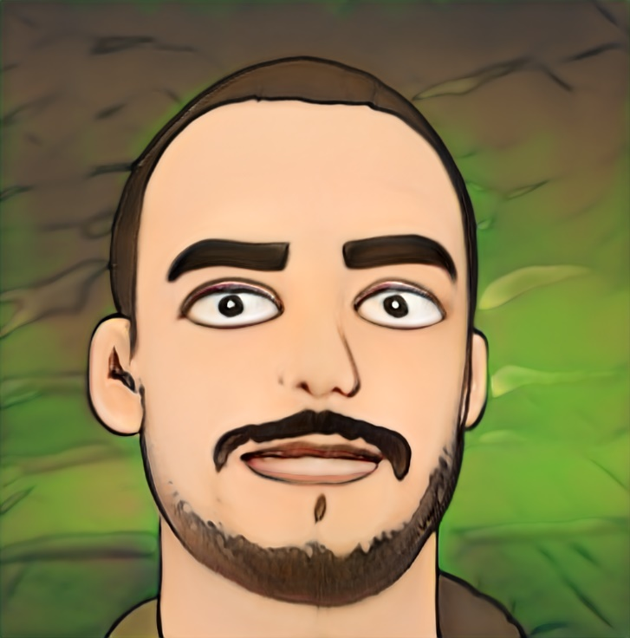

I am a team player equipped with a disruptive mindset: I prefer the unusual solution, the less-traveled road, and I don't give up until I reach my destination.





|  |  |  |
| --- | --- | --- |
| [BACKGROUND](https://opensea.io/assets/boredapeyachtclub?search%5bstringTraits%5d%5b0%5d%5bname%5d=Background&search%5bstringTraits%5d%5b0%5d%5bvalues%5d%5b0%5d=Yellow&search%5bsortAscending%5d=true&search%5bsortBy%5d=PRICE)  [Underground Hip Hop](https://opensea.io/assets/boredapeyachtclub?search%5bstringTraits%5d%5b0%5d%5bname%5d=Background&search%5bstringTraits%5d%5b0%5d%5bvalues%5d%5b0%5d=Yellow&search%5bsortAscending%5d=true&search%5bsortBy%5d=PRICE)  [1.62 % have this trait](https://opensea.io/assets/boredapeyachtclub?search%5bstringTraits%5d%5b0%5d%5bname%5d=Background&search%5bstringTraits%5d%5b0%5d%5bvalues%5d%5b0%5d=Yellow&search%5bsortAscending%5d=true&search%5bsortBy%5d=PRICE)  [Data AnalyTICS](https://opensea.io/assets/boredapeyachtclub?search%5bstringTraits%5d%5b0%5d%5bname%5d=Fur&search%5bstringTraits%5d%5b0%5d%5bvalues%5d%5b0%5d=Solid%20Gold&search%5bsortAscending%5d=true&search%5bsortBy%5d=PRICE)  [Nansen.ai](https://opensea.io/assets/boredapeyachtclub?search%5bstringTraits%5d%5b0%5d%5bname%5d=Fur&search%5bstringTraits%5d%5b0%5d%5bvalues%5d%5b0%5d=Solid%20Gold&search%5bsortAscending%5d=true&search%5bsortBy%5d=PRICE)  [8.15% have this trait](https://opensea.io/assets/boredapeyachtclub?search%5bstringTraits%5d%5b0%5d%5bname%5d=Fur&search%5bstringTraits%5d%5b0%5d%5bvalues%5d%5b0%5d=Solid%20Gold&search%5bsortAscending%5d=true&search%5bsortBy%5d=PRICE) | Mustache  Kulak  2.38% have this trait  Programming  JavaScript and Solidity  7.2% have this trait | STRENGTH  Detailed insights  0.59% have this trait  OTHER LANGUAGES  Romanian and French  3% have this trait |

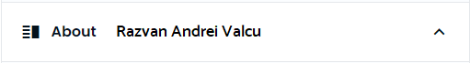

**Binance NFT Analyst Intern (NFT/GameFi) #0001**



